**MAHARASHTRA STATE BOARD OF TECHNICAL EDUCATION**

**VIDYAVARDHINI’SBHAUSAHEB VARTAK POLYTECHNIC**

**MICRO PROJECT**

**Academic year: 2020-21**

**TOURS AND TRAVELS WEBSITE**

**Program/Code: Computer Engineering (CO) Semester: FIFTH**

**Course/Code: CSS (22519) Seat No:**

**Name: Enrolment No:**

**Name of Faculty:** Prof. Parvez Vaghela

**Group No.:**

|  |  |  |  |
| --- | --- | --- | --- |
| **Sr. No.** | **Roll No.** | **Name** | **Enrolment No.** |
| 1. | 1933 | Sagar Shah | 1800930104 |
| 2. | 1935 | Nimish Vartak | 1800930108 |
| 3. | 1936 | Kaustubh M Patil | 1800930109 |

**MAHARASHTRA STATE BOARD OF TECHNICAL EDUCATION**



**CERTIFICATE**

This is to certify that Mr. /Ms.………………………………………

Roll No: …….... of **Fifth** Semester of Diploma in **Computer Engineering** of

Institute, B.V. POLYTECHNIC (Code: **0093**) has completed the **Micro Project** satisfactorily in **Subject CSS (22519)** for the academic year 2020- 2021 as prescribed in the curriculum.

**Place: Vasai Enrolment No: ………………………**

**Date: ……………………… Exam. Seat No: ………………………**

**Subject Teacher Head of the Department Principal**

**Seal**

**of**

**Institution**

**Annexure - I**

**Part A: Micro Project Proposal**

1. **Aim/Benefits of the Micro-Project:**

**2.0 Action Plan**

|  |  |  |  |  |
| --- | --- | --- | --- | --- |
| **Sr. No.** | **Details of the activity** | **Planned Start date** | **Planned Finish date** | **Name of Members** |
|  | Formation of Group & Topic Selection |  |  | All members |
|  | Submission of Proposed Plan |  |  | All members |
|  | Preparation of Report |  |  | All members |
|  | Final valuation of a working Report |  |  | All members |
|  | Presentation of Report |  |  | All members |
|  | Submission of Final Report |  |  | All members |

**3.0 Resources Required**

|  |  |  |  |  |
| --- | --- | --- | --- | --- |
| **Sr. No.** | **Name of resources/Material** | **Specifications** | **Qty** | **Remarks** |
|  | Computer | Intel i5-7200U, 4 GB RAM, 1 TB HDD | **1** |  |
|  | Operating System | Windows 10 Pro | **1** |  |
|  | Web Browser | Google Chrome | **1** |  |
|  | Microsoft Office Word | MS Office 2010 | **1** |  |

**4.0 Names of Team Members with Roll No:**

|  |  |  |  |
| --- | --- | --- | --- |
| **Sr. No.** | **Roll No.** | **Name** | **Enrolment No.** |
| 1. | 1933 | Sagar Shah | 1800930104 |
| 2. | 1935 | Nimish Vartak | 1800930108 |
| 3. | 1936 | Kaustubh M Patil | 1800930109 |

**Name & Signature of Faculty**

**Annexure- II**

**Final Micro Project Report**

**Title: Tours and Travels Website**

1. **Rationale:**
2. **Aim/Benefits of the Micro-Project:**
3. **Course Outcomes Integrated:**
4. **Actual Procedure Followed.**

1 Discussion about topic with guide and among group members

2 Literature survey

1. Information collection
2. Compilation of content
3. Editing and revising content
4. Report Preparation

**5.0 Actual Resources Required**

|  |  |  |  |  |
| --- | --- | --- | --- | --- |
| **Sr. No.** | **Name of resources/Material** | **Specifications** | **Qty** | **Remarks** |
|  | Computer | Intel i5-7200U, 4 GB RAM, 1 TB HDD | **1** |  |
|  | Microsoft Office Word | MS Office 2010 | **1** |  |

1. **Skill Developed/Learning outcomes of this Micro-Project**

**Annexure - III**

**Rubrics for Assessment of Micro-Project**

**Title: Tours and Travels Website**

**Institute Code:** 0093 **Academic year:** 2020-21

**Program:** CO-II **Course & Code:** CSS (22519)

**Name of Candidate: Roll No:**

**Seat No:**

**Semester:** FIFTH  **Name of Faculty: Prof. Parvez Vaghela**

|  |  |  |  |  |  |
| --- | --- | --- | --- | --- | --- |
| **Sr. No.** | **Characteristic to be Assessed** | **Poor**  (Marks 1-3) | **Average**  (Marks 4-5) | **Good**  (Marks 6-8) | **Excellent**  (Marks 9-10) |
| 1. | Relevance to the Course |  |  |  |  |
| 2. | Literature Survey/Information Collection |  |  |  |  |
| 3. | Project Proposal |  |  |  |  |
| 4. | Completion of the Target as per Project Proposal |  |  |  |  |
| 5. | Analysis of Data and Representation |  |  |  |  |
| 6. | Quality of Prototype/Model |  |  |  |  |
| 7. | Report Preparation |  |  |  |  |
| 8. | Presentation |  |  |  |  |
| 9. | Defence |  |  |  |  |

**Micro-Project Evaluation Sheet**

**Title:** **Tour Booking Management System**

**Institute Code:** 0093 **Academic year:** 2020-21

**Program:** CO-II **Course & Code:** CSS (22519)

**Name of Candidate: Roll No:**

**Seat No:**

**Semester:** FIFTH **Name of Faculty: Prof. Parvez Vaghela**

**Course Outcomes Achieved:**

1. Apply various software testing methods.
2. Prepare test cases for different types and levels of testing.
3. Prepare test plan for an application.

**Evaluation as per Suggested Rubric for Assessment of Micro Project:**

|  |  |  |  |  |  |  |
| --- | --- | --- | --- | --- | --- | --- |
| **Sr. No.** | **Characteristic to be assessed** | **Poor Marks**  **1-3** | **Average Marks 4-5** | **Good Marks**  **6-8** | **Excellent**  **Marks 9-10** | **Sub Total** |
| 1. **Process and product assessment Out Of 6** | | | | | | |
| 1 | Relevance to the course |  |  |  |  |  |
| 2 | Literature Survey Information Collection |  | . |  |  |
| 3 | Completion of the Target as per project proposal |  |  |  |  |
| 4 | Analysis of Data and representation |  |  |  |  |
| 5 | Quality of Prototype/Model/Content |  |  |  |  |
| 6 | Report Preparation |  |  |  |  |
| 1. **Individual Presentation/Viva Out of 4** | | | | | | |
| 7 | Presentation | . |  |  |  |  |
| 8 | Viva |  |  |  |  |

|  |  |  |  |  |
| --- | --- | --- | --- | --- |
| **Roll No.** | **Name of Students** | **Process and Product assessment out of 6** | **Individual**  **Presentation Marks out of 4** | **Total out of 10** |
| 1933 | Sagar Shah |  |  |  |
| 1935 | Nimish Vartak |  |  |  |
| 1936 | Kaustubh M Patil |  |  |  |

**Comments/Suggestions about team work/leadership/inter-personal communication (if any):**

**Any other Comments:**

**Name and designation of the Faculty Member:**

**Signature**

**Weekly Activity Sheet**

**Topic: Tour Booking Management System**

**Institute Code:** 0093 **Academic year:** 2020-21

**Program:** CO-II **Course & Code:** CSS (22519)

**Name of Candidate: Roll No:**

**Seat No:**

**Semester:** FIFTH **Name of Faculty: Prof. Parvez Vaghela**

|  |  |  |
| --- | --- | --- |
| **SR. NO** | **WEEK** | **ACTIVITY PERFORMED** |
| 1. | 1st Week | Discussion and Finalization of Topic |
| 2. | 2nd Week | Literature Review |
| 3. | 3rd Week | Submission of Proposed Plan |
| 4 | 4th Week | Information Collection |
| 5. | 5th Week | Analysis of Data |
| 6. | 6th Week | Compilation of content |
| 7. | 7th Week | Editing and Revising the Content |
| 8. | 8th Week | Report Presentation |
| 9. | 9th Week | Report Presentation |
| 10. | 10th- 12th Week | Presentation |

**Signature of Student Dated Signature of Faculty**

**INDEX**

|  |  |  |
| --- | --- | --- |
| Sr. No. | Topic | Pg. No. |
|  | Title | 1 |
|  | Certificate | 2 |
|  | Annexure-I | 3 |
|  | Annexure-II | 4 |
|  | Annexure-III | 5 |
|  | Micro project evaluation sheet | 6-7 |
|  | Weekly Activity Sheet | 8 |
|  | Index | 9 |
|  | Introduction | 10 |
|  | Title: Tours and Travels | 12 |
|  | Source Code | 13 |
|  | Code Output | 24 |
|  | Conclusion | 29 |
|  | Reference | 30 |

# **INTRODUCTION**

JavaScript is the dominant client-side scripting language of the Web, with 95% of websites using it for this purpose. Scripts are embedded in or included

from HTML documents and interact with the DOM. All major web browsers have a built- in JavaScript engine that executes the code on the user's device.

The use of JavaScript has expanded beyond its web browser roots. JavaScript engines are now embedded in a variety of other software systems, both for server-side website deployments and non-browser applications.

Initial attempts at promoting server-side JavaScript usage were Netscape Enterprise

Server and Microsoft's Internet Information Services, but they were small niches. Server-side usage eventually started to grow in the late-2000s, with the creation of Node.js and other approaches.

Electron, Cordova, and other software frameworks have been used to create many applications with behaviour implemented in JavaScript. Other non-browser applications include Adobe Acrobat support for scripting PDF documents and GNOME Shell extensions written in JavaScript.

JavaScript has recently begun to appear in some embedded systems, usually by leveraging Node.js.

Alongside HTML and CSS, JavaScript is one of the core technologies of the World Wide Web. JavaScript enables interactive web pages and is an essential part of web applications. The vast majority of websites use it for client-side page behaviour, and all major web browsers have a dedicated JavaScript engine to execute it.

As a multi-paradigm language, JavaScript supports event-driven, functional,

and imperative programming styles. It has application programming interfaces (APIs) for working with text, dates, regular expressions, standard data structures, and the Document Object Model (DOM). However, the language itself does not include any input/output (I/O), such as networking, storage, or graphics facilities, as the host environment (usually a web browser) provides those APIs.

JavaScript engines were originally used only in web browsers, but they are now embedded in some servers, usually via Node.js. They are also embedded in a variety of applications created with frameworks such as Electron and Cordova.

Although there are similarities between JavaScript and Java, including languagename, syntax, and respective standard libraries, the two languages are distinct and differ greatly in design.

**Web design**

web design encompasses many different skills and disciplines in the production and maintenance of websites. The different areas of web design include web graphic design; user interface design (UI design); authoring, including standardised code and proprietary software; user experience design (UX design); and search engine optimization. Often many individuals will work in teams covering different aspects of the design process, although some designers will cover them all. The term "web design" is normally used to describe the design process relating to the front-end (client side) design of a website including

writing mark up. Web design partially overlaps web engineering in the broader scope of web development. Web designers are expected to have an awareness of usability and if their role involves creating mark up then they are also expected to be up to date with web accessibility guidelines.

**Tools and Technologies**

Web designers use a variety of different tools depending on what part of the production process they are involved in. These tools are updated over time by newer standards and software but the principles behind them remain the same. Web designers use

both vector and raster graphics editors to create web-formatted imagery or design prototypes. Technologies used to create websites include W3C standards like HTML and CSS, which can be hand-coded or generated by WYSIWYG editing software. Other tools web designers might use include mark up validators and other testing tools for usability and accessibility to ensure their websites meet web accessibility guidelines.

**Marketing and communication design**

Marketing and communication design on a website may identify what works for its target market. This can be an age group or particular strand of culture; thus, the designer may understand the trends of its audience. Designers may also understand the type of website they are designing, meaning, for example, that (B2B) business-to-business website design considerations might differ greatly from a consumer targeted website such as a retail or entertainment website. Careful consideration might be made to ensure that the aesthetics or overall design of a site do not clash with the clarity and accuracy of the content or the ease of web navigation, especially on a B2B website. Designers may also consider the reputation of the owner or business the site is representing to make sure they are portrayed favourably

**TITLE :TOURS AND TAVELS**

Here we have developed a project on Tour and Travel. Online Tour and Travel Booking is a system that gives you the facility of booking any type of packages. This system is made, so that customer can easily book ticket for all packages of tourist places such as hills, trekking, adventures, spirituals. The project ‘Tours and Travels’ is developed to replace the currently existing system, which helps in keeping records of the customer, details of destination as well as payment received. Payment gateway is also available in this site.

The objective of the project is to develop a system that automates the processes and activities of a travel and. The purpose is to design a system using which one can perform all operations related to traveling.

**SOURCE CODE:**

**Main page of website booking page:( Index page)**

<!DOCTYPE html>

<html>

<head>

  <meta name="viewport" content="width=device-width, initial-scale=1">

  <title> Explore Travels N Tours </title>

  <link rel="stylesheet" href="https://cdnjs.cloudflare.com/ajax/libs/font-awesome/4.7.0/css/font-awesome.min.css">

  <style>

    body {

      font-family: "Lato", sans-serif;

      display: flex;

    }

    .sidebar {

      height: 120vh;

      /* width: 250px; */

      /* position: fixed; */

      /* z-index: 1; */

      background-color: #111;

      overflow-x: hidden;

      padding-top: 16px;

      display: flex;

      flex-direction: column;

      align-items: center;

      flex: 1;

    }

    .container {

      flex: 5

    }

    .sidebar a {

      padding: 6px 8px 6px 16px;

      text-decoration: none;

      font-size: 20px;

      color: rgb(235, 233, 204);

      display: block;

    }

    .sidebar a:hover {

      color: rgb(156, 66, 6);

    }

    .main {

      /* margin-left: 200px; */

      /* Same as the width of the sidenav */

      padding: 0px 30px;

    }

    .sidebar img {

      width: 40%;

    }

    .sidebar .logo {

      display: flex;

      justify-content: center;

      align-items: center;

    }

    .sidebar .links {

      display: flex;

      flex-direction: column;

      align-items: flex;

    }

    @media screen and (max-height: 450px) {

      .sidebar {

        padding-top: 18px;

      }

      .sidebar a {

        font-size: 28px;

      }

    }

    body {

      background-image: url("https://source.unsplash.com/1600x900/?pub");

      background-size: cover;

    }

    .main {

      display: flex;

      align-items: center;

      justify-content: center;

      background-color: #111111;

      margin: 0;

      width: 98%;

      padding: 10px;

    }

    * {

      margin: 0;

    }

    .main img {

      width: 5%;

      padding: 0 10px;

    }

    .main h1 {

      color: white;

    }

    .main-container {

      display: flex;

      align-items: center;

      flex-direction: column;

      height: 80%;

    }

    .row {

      display: flex;

      justify-content: space-around;

      align-items: center;

      width: 100%;

    }

    .row img {

      padding: 15px;

      width: 45%;

    }

  </style>

</head>

<body>

  <div class="sidebar">

    <div class="logo">

      <img src="./img/logo.jpeg" alt="">

    </div>

    <hr width="80%">

    <div class="links">

      <a href="booking.html"target="_blank"><i class="fa fa-fw fa-home"></i> Home</a>

      <a href="./contact.html" target="_blank"><i class="fa fa-fw fa-phone"></i> Contact</a>

      <a href="https://www.instagram.com/flighttour/" target="_blank"><i class="fa fa-fw fa-instagram"></i> Instagram

      </a>

      <a href="https://hippie-inheels.com/essential-travel-items/" target="_blank"><i

          class="fa fa-fw fa-check-square"></i>

        Essential-travel-items</a>

      <a href=" https://www.google.com/maps/" target="blank" ><i class="fa fa-fw fa-map-o"></i> Map </a>

      <a href=" https://www.tripadvisor.in/ShowForum-g293860-i511-India.html/" target="_blank"><i

          class="fa fa-fw fa-commenting-o"></i> Our forum </a>

    </div>

  </div>

  <div class="container">

    <div class="main">

      <img src="./img/logo.jpeg" alt="">

      <h1> Explore Travels and Tours  </h1>

    </div>

    <div class="main-container">

      <div class="row">

        <img src="https://source.unsplash.com/1600x900/?bar" alt="">

        <img src="https://source.unsplash.com/1600x900/?lens" alt="">

      </div>

      <div class="row">

        <img src="https://source.unsplash.com/1600x900/?travels" alt="">

        <img src="https://source.unsplash.com/1600x900/?nightlife" alt="">

      </div>

    </div>

  </div>

</body>

</html>

**Booking page 2nd page:(Booking Page)**

<!DOCTYPE html>

<html>

<head>

  <meta http-equiv="X-UA-Compatible" content="IE=edge,chrome=2" />

  <title>Tours & Travels</title>

  <meta name="description" content="" />

  <meta name="viewport" content="width=device-width, initial-scale=1" />

  <link rel="stylesheet" href="css/bootstrap.min.css" />

  <link rel="stylesheet" href="css/bootstrap-theme.min.css" />

  <link rel="stylesheet" href="css/fontAwesome.css" />

  <link rel="stylesheet" href="css/hero-slider.css" />

  <link rel="stylesheet" href="css/owl-carousel.css" />

  <link rel="stylesheet" href="css/datepicker.css" />

  <link rel="stylesheet" href="css/tooplate-style.css" />

  <link rel="stylesheet" href="./css/style.css" />

</head>

<script type="text/javascript">

  function showokay() {

    alert("Your tickets have been booked, please check your respective mail for tickets. Thankyou for booking with Explore Travels and Tours! Wish you a happy journey ");

  }

</script>

<body>

  <section class="banner" id="bottom">

    <div class="container">

      <div class="row">

        <div class="col-md-1">

          <div class="flex">

            <div class="right-side">

              <div class="logo">

                <img src="img/logo.jpeg" />

              </div>

              <div class="page-direction-button">

                <a href="contact.html"><i class="fa fa-phone"></i>Contact Us Now</a>

              </div>

            </div>

          </div>

        </div>

        <div class="col-md-5 col-md-offset-5">

          <div class="submit-form">

            <h4>Check availability for <em>travel package</em>:</h4>

            <form id="form-submit" action="" method="get">

              <div class="row">

                <div class="col-md-6">

                  <fieldset>

                    <label for="from">From:</label>

                    <select required name="from" onchange="this.form()">

                      <option value="">Select a location...</option>

                      <option value="Cambodia">Cambodia</option>

                      <option value="Hong Kong">Hong Kong</option>

                      <option value="India">India</option>

                      <option value="Japan">Japan</option>

                      <option value="Korea">Korea</option>

                      <option value="Laos">Laos</option>

                      <option value="Myanmar">Myanmar</option>

                      <option value="Singapore">Singapore</option>

                      <option value="Thailand">Thailand</option>

                      <option value="Vietnam">Vietnam</option>

                    </select>

                  </fieldset>

                </div>

                <div class="col-md-6">

                  <fieldset>

                    <label for="to">To:</label>

                    <select required name="to" onchange="this.form()">

                      <option value="">Select a location...</option>

                      <option value="Cambodia">Cambodia</option>

                      <option value="Hong Kong">Hong Kong</option>

                      <option value="India">India</option>

                      <option value="Japan">Japan</option>

                      <option value="Korea">Korea</option>

                      <option value="Laos">Laos</option>

                      <option value="Myanmar">Myanmar</option>

                      <option value="Singapore">Singapore</option>

                      <option value="Thailand">Thailand</option>

                      <option value="Vietnam">Vietnam</option>

                    </select>

                  </fieldset>

                </div>

                <div class="col-md-6">

                  <fieldset>

                    <label for="departure">Departure date:</label>

                    <input name="deparure" type="date" class="form-control date" id="deparure"

                      placeholder="Select date..." required="" onchange="this.form()" />

                  </fieldset>

                </div>

                <div class="col-md-6">

                  <fieldset>

                    <label for="return">Return date:</label>

                    <input name="return" type="date" class="form-control date" id="return" placeholder="Select date..."

                      required="" onchange="this.form()" />

                  </fieldset>

                </div>

                <div class="col-md-6">

                  <div class="radio-select">

                    <div class="row">

                      <div class="col-md-6 col-sm-6 col-xs-6">

                        <label for="round">Round</label>

                        <input type="radio" name="trip" id="round" value="round" required="required"

                          onchange="this.form()" />

                      </div>

                      <div class="col-md-6 col-sm-6 col-xs-6">

                        <label for="oneway">Oneway</label>

                        <input type="radio" name="trip" id="oneway" value="one-way" required="required"

                          onchange="this.form()" />

                      </div>

                    </div>

                  </div>

                </div>

                <div class="package-button">

                  <fieldset>

                    <button type="submit" id="form-submit" class="btn" onclick='showokay()'>

                      Book Package

                    </button>

                  </fieldset>

                </div>

              </div>

            </form>

          </div>

        </div>

      </div>

    </div>

    </div>

  </section>

</body>

</html>

**Contact page 3rd page:(Contact Us Page)**

<!DOCTYPE html>

<html>

    <head>

        <meta charset="utf-8">

        <title> Contact Us Page</title>

        <meta name="description" content="">

        <meta name="viewport" content="width=device-width, initial-scale=1">

        <link rel="stylesheet" href="css/bootstrap.min.css">

        <link rel="stylesheet" href="css/bootstrap-theme.min.css">

        <link rel="stylesheet" href="css/fontAwesome.css">

        <link rel="stylesheet" href="css/hero-slider.css">

        <link rel="stylesheet" href="css/owl-carousel.css">

        <link rel="stylesheet" href="css/tooplate-style.css">

        <link href="https://fonts.googleapis.com/css?family=Spectral:200,200i,300,300i,400,400i,500,500i,600,600i,700,700i,800,800i" rel="stylesheet">

        <link href="https://fonts.googleapis.com/css?family=Roboto:100,300,400,500,700,900" rel="stylesheet">

        <scrip type="text/javascript">

            function onsubmitmessg()

            {

                alert("Thanks! for letting us know.");

            }

        </scrip>

    </head>

<body>

 <section class="page-heading" id="bottom">

        <div class="container">

            <div class="row">

                <div class="col-md-2">

                    <div class="logo">

                        <img src="img/logo.jpeg" >

                    </div>

                </div>

                <div class="col-md-6">

                    <div class="page-direction-button">

                        <a href="index.html"><i class="fa fa-home"></i>Go Back Home</a>

                    </div>

                </div>

            </div>

        </div>

    </section>

    <section class="contact-us">

        <div class="container">

            <div class="row">

                <div class="col-md-12">

                    <div class="section-heading">

                        <h2>Contact Information</h2>

                        <p>

                        </p>

                    </div>

                </div>

                <div class="col-md-6">

                    <img src="img/j.jpeg" alt="">

                </div>

                <div class="col-md-6">

                    <img src="img/k.jpeg" alt="">

                </div>

                <div class="col-md-4">

                    <h6>Travellers History</h6>

                    <p>Travel dates back to antiquity where wealthy Greeks and Romans would travel for leisure to their summer homes and villas

                         in cities such as Pompeii and Baiae. While early travel tended to be slower, more dangerous, and more dominated by

                         trade and migration, cultural and technological advances over many years have tended to mean that travel has become

                         easier and more accessible. Mankind has come a long way in transportation since Christopher Columbus

                         sailed to the new world from Spain in 1492, an expedition which took over 10 weeks to arrive at the final

                          destination; to the 21st century where aircraft allow travel from Spain to the United States overnight.</p>

                </div>

                <div class="col-md-4">

                    <h6>Meet the Nature, find yourself</h6>

                    <p>Authorities emphasize the importance of taking precautions to ensure travel safety.

                        When traveling abroad, the odds favor a safe and incident-free trip, however,

                        travelers can be subject to difficulties, crime and violence. Some safety considerations include being

                        aware of one's surroundings,avoiding being the target of a crime, leaving copies of one's passport and itinerary

                        information with trusted people, obtaining medical insurance valid in the country being visited and registering with

                       one's national embassy when arriving in a foreign country.

                       Many countries do not recognize drivers' licenses from other countries;

                       however most countries accept international driving permits.</p>

                </div>

                <div class="col-md-4">

                    <h6> Science learning with tourism and traveling</h6>

                    <p>Science tourism is a travel topic grouping scientific attractions.

                        It covers interests in visiting and exploring scientific landmarks,

                         including museums, laboratories, observatories and universities.[1][2]

                         It also includes visits to see events of scientific interest, such as solar eclipses.

 A laboratory is a workplace and many have ongoing scientific research. They may not be open to the general public,

 or may only offer occasional special opportunities for public access.

 Many observatories are open to the public at regular hours, and have tours showcasing their astronomical research</p>

                </div>

            </div>

        </div>

    </section>

    <section class="contact-form">

        <div class="container">

            <div class="row">

                <div class="col-md-12">

                    <div class="section-heading">

                        <h2>Leave us a message</h2>

                    </div>

                </div>

                <div class="col-md-6 col-md-offset-3">

                    <form id="contact" action="#" method="post">

                        <div class="row">

                            <div class="col-md-6">

                                <fieldset>

                                    <input name="name" type="text" class="form-control" id="name" placeholder="Your name..." required="">

                                </fieldset>

                            </div>

                            <div class="col-md-6">

                                <fieldset>

                                    <input name="email" type="text" class="form-control" id="email" placeholder="Your email..." required="">

                                </fieldset>

                            </div>

                            <div class="col-md-12">

                                <fieldset>

                                    <textarea name="message" rows="6" class="form-control" id="message" placeholder="Your message..." required=""></textarea>

                                </fieldset>

                            </div>

                            <div class="col-md-12">

                                <fieldset>

                                    <button type="submit" id="form-submit" class="btn" onclick="onsubmitmessg()">Submit Your Message</button>

                                </fieldset>

                            </div>

                        </div>

                    </form>

                </div>

            </div>

        </div>

    </section>

</body>

</html>

# **CODE OUTPUT:**

# **Explore Travels and Tours website(index.html)A screenshot of a video game Description automatically generated:**

# **Booking page:**

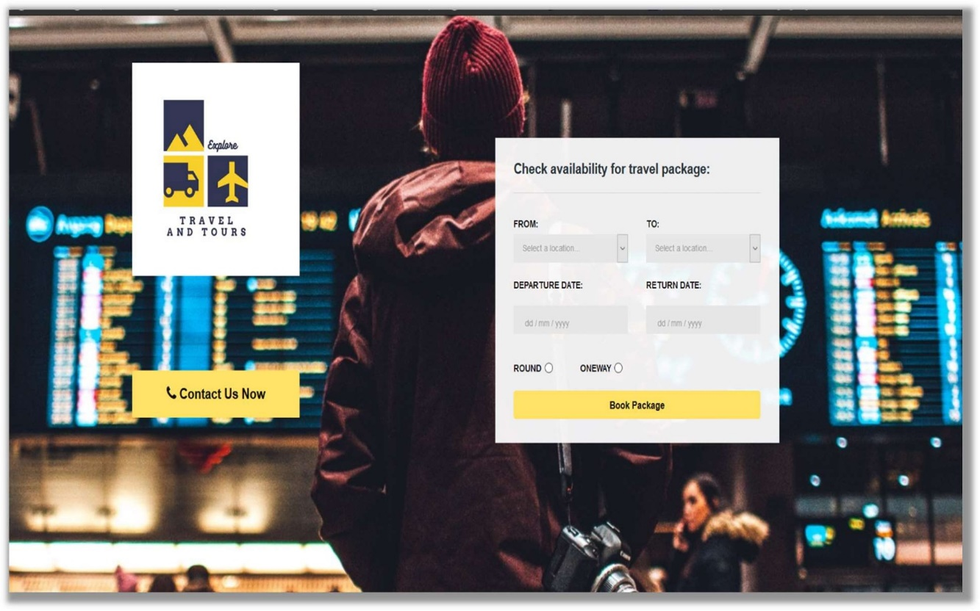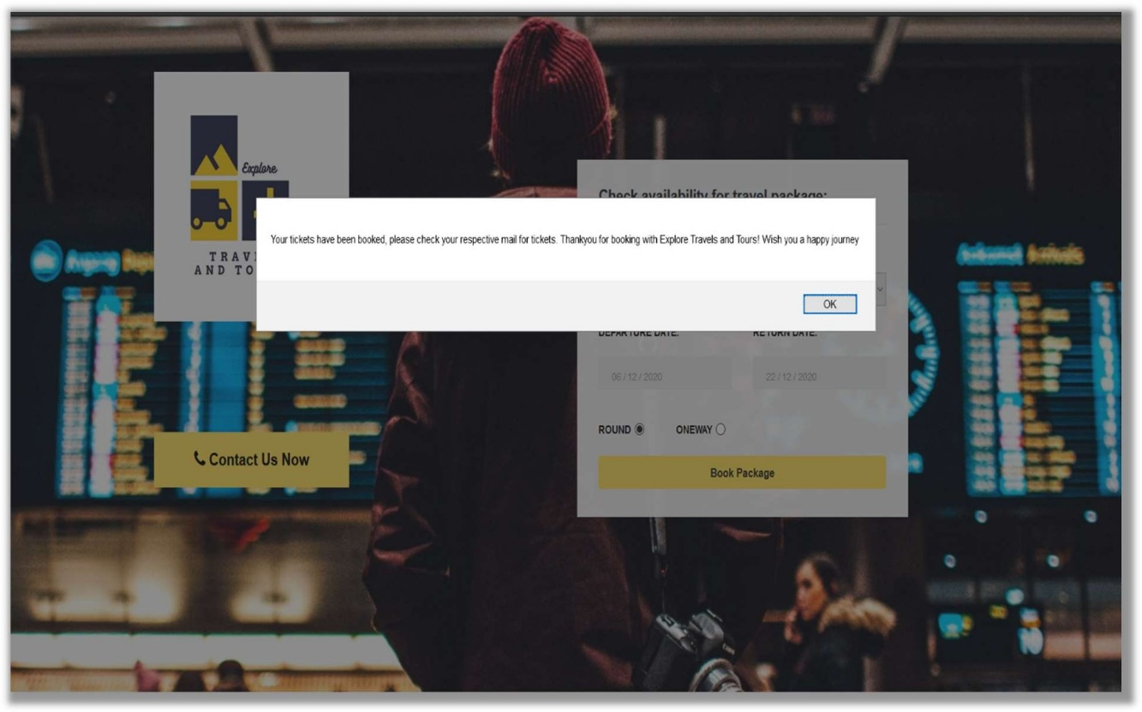

**Contact Us Page:**

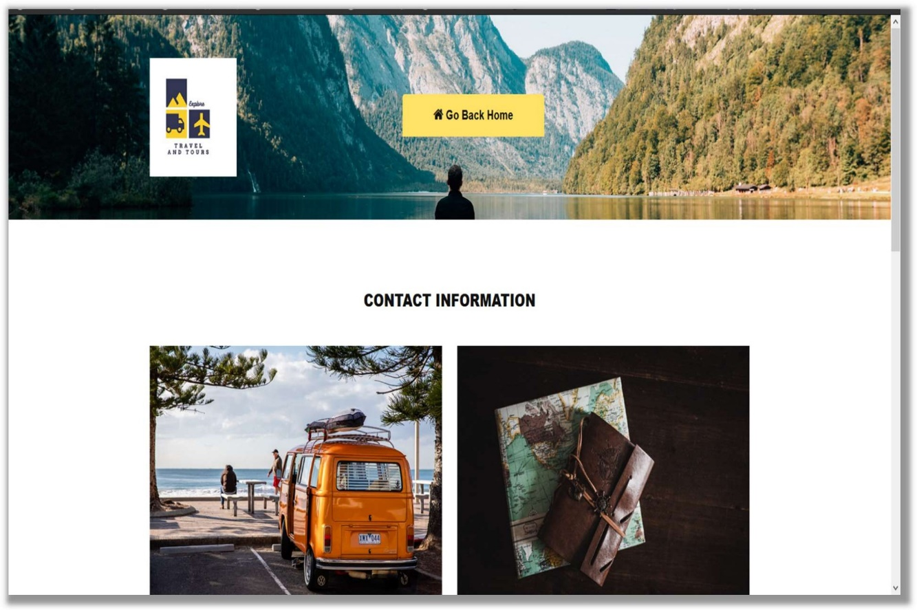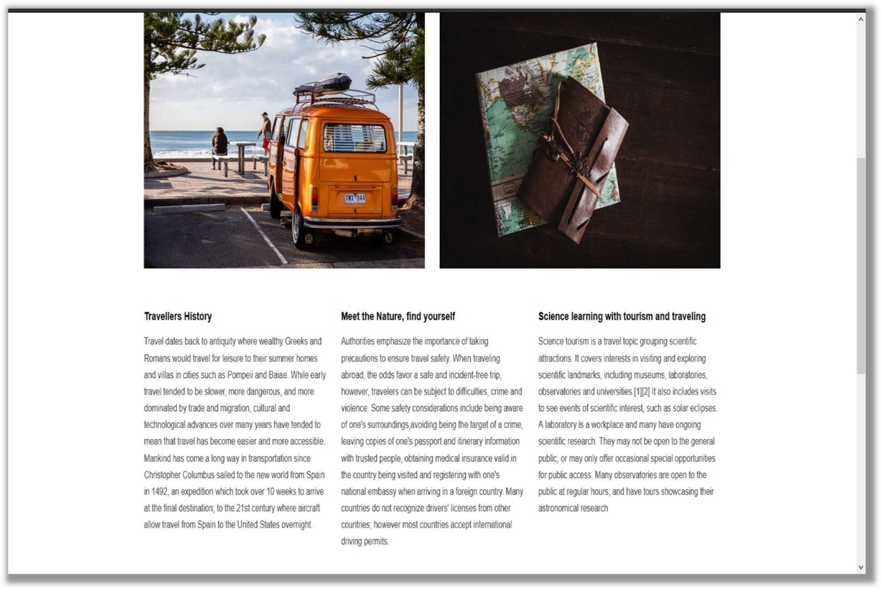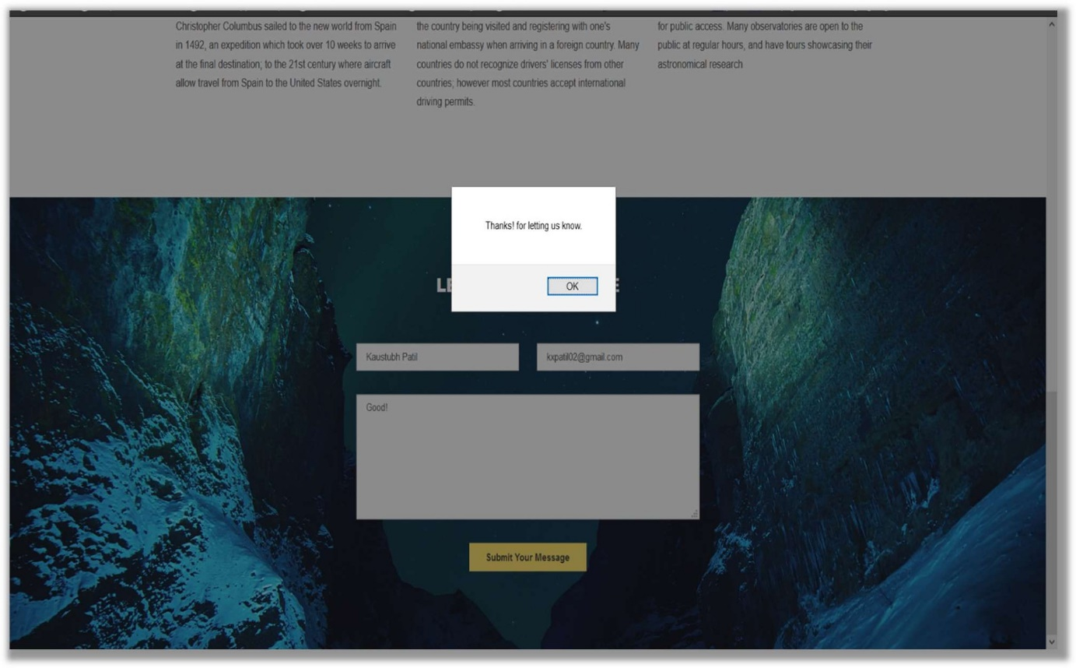

**CONCLUSION:-**

Thus, we have successfully created a website for tourism and travelling purpose. By using languages as: html, javaScript, Css and bootstrap themes.

The main page sof website contains menus of booking and contacts and different plateforms, by using css and bootstrap language, which is successfully achieved. In this website we have categorized different countries and amazing places from different continents, also travelling a oneway trip or a round trip that depends on the user accessing website.

We have used VsCode Editor, that helped us to ease our work.

**Reference :-**

**https://www.slideshare.net/mobile/mksmadhukar/travel-and-tourism-management-it-project#:~:text=CONCLUSION%20%E2%80%A2%20%E2%80%9CTravel%20and%20tourism,the%20management%20process%20in%20travelling.&text=Fast%20processing%20and%20immediate%20results%20with%20high%20security.&text=Minimizing%20human%20effort%20and%20cost%20efficient%20databases.&text=Navigation%20through%20the%20site%20is%20easy**

[**https://sites.google.com/site/ignoubcafinalyearprojects/project-report/tours-and-travel-management-system-project-report**](https://sites.google.com/site/ignoubcafinalyearprojects/project-report/tours-and-travel-management-system-project-report)

**https://fonts.googleapis.com/css https://**[**www.youtube.com/watch?v=5iC9gyAdEV0**](http://www.youtube.com/watch?v=5iC9gyAdEV0)

**bootstrap.min.css**

**bootstarp-theme.css & style.css**

**https://**[**www.wix.com/html5**](http://www.wix.com/html5) **https://**[**www.w3schools.com/html/html_css.asp**](http://www.w3schools.com/html/html_css.asp) **https://**[**www.w3schools.com/html/html_styles.asp**](http://www.w3schools.com/html/html_styles.asp) **https://**[**www.w3schools.com/html/html_images.asp**](http://www.w3schools.com/html/html_images.asp) **https://**[**www.youtube.com/watch?v=K4aa7ruovg0**](http://www.youtube.com/watch?v=K4aa7ruovg0)